BERMAS, LESTER LANCE J. COMPUTER NETWORKING NOVEMBER 27, 2022

BSIT-NS-3AB LABORATORY PROF. VICENTE ESTEMBER

**ACTIVITY 6**

**ACCESSING AND CONFIGURING ROUTER GATEWAY USING IOS IN CLI**

**OBJECTIVES:**

1. To access Cisco Switch and Router through console cable.
2. Familiarize the IOS CLI basic commands.
3. To understand the IOS modes of operation.
4. To understand the IOS environments.
5. To test initial configuration of router Gateway IP using Command-Line-Interface.

**STEPS AND PROCEDURES:**

1. Prepare the following: IP address (Beginning and Last), subnet mask and its

Default gateway for creating network topologies. Note that the IP address and default gateway must be different for each block, but the subnet mask must be used for every block.

**SUBNET MASK: 255.255.240.0**

|  |  |  |
| --- | --- | --- |
| **Beginning IP Address** | **Last IP Address** | **Default Gateway** |
| 150.168.17.2 | 150.168.31.254 | 150.168.17.1 |
| 150.168.33.2 | 150.168.47.254 | 150.168.33.1 |
| 150.168.49.2 | 150.168.63.254 | 150.168.49.1 |
| 150.168.65.2 | 150.168.79.254 | 150.168.65.1 |
| 150.168.81.2 | 150.168.95.254 | 150.168.81.1 |
| 150.168.97.2 | 150.168.111.254 | 150.168.97.1 |
| 150.168.113.2 | 150.168.127.254 | 150.168.113.1 |
| 150.168.129.2 | 150.168.143.254 | 150.168.129.1 |
| 150.168.145.2 | 150.168.159.254 | 150.168.145.1 |
| 150.168.161.2 | 150.168.175.254 | 150.168.161.1 |

2. Use the table above to create your network topology in Cisco Packet Tracer.

3. Apply the list of addresses and default gateways you created to the table. Place the ports inside the routers in the topology you created and press ON on the routers.

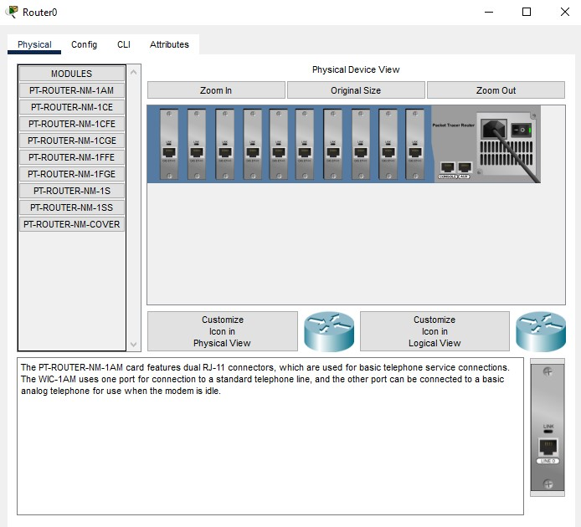

4. Then, go to the laptop and prepare its terminal to assign the following default gateways.

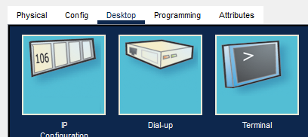

5. This is what the output looks like after clicking Terminal. Then proceed with the IP configuration assigned to the switch using the default gateway created in the table.

6. Enter the following command: These commands are assigned to switches with default gateways listed in the table. Note that it must be in your router path.

These are the following commands that I’ve used:

**enable**

**conf t int (specify the cable used)**

**ip add (default gateway) (subnet mask)**

**no shut**

**exit**

7. Topology automatically connects the following switches from the router: Then assign the following IP addresses (Beginning and Last) under each block (switch) along with the default gateway.

8. Test the network topology. Make sure that all the are successfully connected to each other.

**OBSERVATION AND RESULTS:**

From what I've observed, the following command I used in the CLI works based on the syntax and IP address assigned. The results are very accurate, found using the declared default gateways listed in the previous table. I also noticed that the command declared in step 6 has its own usage: ‘enable’ = command for privilege mode

* conf t = configuration mode
* int (cable used) = interface for the specified cable and its number
* ip add (default gateway) (mask) = assigns IP Address (Default Gateway) and a subnet mask
* no shut = brings up the interface
* exit = return to the privilege mode

Additionally, Figure 1 shows the commands reflected in the topology with IP addresses and masks assigned to each block. where the IP address is the default gateway, the mask is static (that is, 255.255.240.0), and Figure 2 shows the assignments. A starting and ending IP address for each block with a default gateway that serves as a complete step for a successful network topology. These are the outputs:

**FIGURE 1:**

|  |  |
| --- | --- |
| Default Gateway for  Switch 1 (Gigabit 0/0): 150.168.17.1 |  |
| Default Gateway for  Switch 2 (Gigabit 1/0): 150.168.33.1 |  |

|  |  |
| --- | --- |
| Default Gateway for  Switch 3 (Gigabit 2/0): 150.168.49.1 |  |
| Default Gateway for  Switch 4 (Gigabit 3/0): 150.168.65.1 |  |
| Default Gateway for  Switch 5 (Gigabit 4/0): 150.168.81.1 |  |
| Default Gateway for  Switch 6 (Gigabit 5/0): 150.168.97.1 |  |
| Default Gateway for Switch 7 (Gigabit 6/0): 150.168.113.1 |  |
| Default Gateway for Switch 8 (Gigabit 7/0): 150.168.129.1 |  |
| Default Gateway for Switch 9 (Gigabit 8/0): 150.168.145.1 |  |
| Default Gateway for  Switch 10 (Gigabit 9/0): 150.168.161.1 |  |

**FIGURE 2:**

|  |  |  |
| --- | --- | --- |
| 1ST  BLOCK |  |  |
| 2nd  BLOCK |  |  |
| 3RD  BLOCK |  |  |
| 4th  BLOCK |  |  |
| 5th  BLOCK |  |  |
| 6th  BLOCK |  |  |
| 7th  BLOCK |  |  |
| 8th  BLOCK |  |  |
| 9th  BLOCK |  |  |
| 10th  BLOCK |  |  |

**CONCLUSIONS:**

Finally, Activity 6, show how to use the command line interface to assign network topology in real computer networks. The Cisco IOS CLI provides an interface for configuring, monitoring, and maintaining Cisco devices that direct and execute commands in real-world computer network applications.